CARDIO VASCULAR DISEASE PREDICTION SYSTEM

Team 7

MINI PROJECT REPORT
Submitted By
AMRUTHA P NAIR
ERSA NIZAR
SHAMIYA C.K
MANEESHA. K



ICT ACADEMY OF KERALA
(A Govt. of India supported, Govt. of Kerala partnered Social Enterprise)

ABSTRACT

Cardiovascular diseases (CVDs) are a group of disorders of the heart and blood vessels. Cardio vascular disease accounts for the majority of death all over the world. This makes CVD detection an important task in health care industry.

It is better to be accurate and precise in detecting diseases early than repenting later. Therefore, it is necessary to have a good prediction framework that can effectively predict cardiovascular disease at the earliest based on the available medical records.

Our aim is to build an efficient and accurate machine learning model that can classify the patients to be healthy or suffering from cardiovascular disease based on the available attributes in the dataset. The publically available cardio vascular disease dataset from Kaggle is used in this study. The task is to classify a person to healthy or suffering from heart disease based on the given data. We have used data science techniques and visualization for this study.

CONTENTS

- INTRODUCTION

- PROBLEM STATEMENT

- DATASET DESCRIPTION

- PROPOSED METHOD
  - IMPORTING THE MODULES REQUIRED
  - LOAD THE DATASET
  - DATA PREPARATION AND DATA PREPROCESSING
  - DATA VISUALIZATION
  - FEATURE ENGINEERING
  - FEATURE SCALING
  - DATA MODELLING

- RESULT AND ANALYSIS

- CONCLUSION
1. INTRODUCTION

Cardiovascular disease (CVD) is a class of diseases that involves the heart or blood vessels. CVD includes coronary artery diseases (CAD) such as angina and myocardial infarction (commonly known as a heart attack). Cardio vascular disease is a significant reason for increased death rate all over the world.

Therefore, it is necessary to have a good prediction framework that can effectively predict cardiovascular disease at the earliest based on the available medical records because misclassification of a diseased person as healthy is more dangerous and may incur heavy loss.

Here our main task is to build a machine learning model that can classify the patient to classify whether healthy or suffering from cardiovascular disease based on the available attributes in the dataset. Several constrains were placed on the selection of these instances from a larger database.

The dataset consists of several medical predictor variables and one target variable. Cardio vascular disease predictor variables include age, height, weight, gender, systolic blood pressure, diastolic blood pressure, cholesterol, alcohol intake, smoking etc. Pre-processing is done on the collected dataset to fill in the missing values and handling the outliers. After effectively ﬁlling out the incomplete dataset, machine learning algorithms like Logistic regression, KNN, SVM, Random forest, Decision tree, Gradient boosting, XG boosting are used to establish models.

2. PROBLEM STATEMENT

The problem statement here is to build a machine learning model to accurately predict whether a person is healthy or suffering from cardiovascular disease based on the given attributes in the dataset. Since we have to predict whether a person has CVD or not it is a supervised learning problem. We have 2 values in target variable (cardio), where 0 denotes person is healthy and 1 denotes person has CVD.

3.DATASET DESCRIPTION

The publically available cardio vascular disease dataset from Kaggle is used for this study.

https://www.kaggle.com/sulianova/cardiovascular-disease-dataset

The dataset consist of 70000 patients records with 12 features and 1 target.

There are 3 types of input features:
- Objective: factual information
- Examination: results of medical examination
- Subjective: information given by the patient.

Attribute | Description
id | Patient id
age | Age of the patient in days (objective feature)
height | Height of the patient in cm (objective feature)
weight | Weight of the patient in kg (objective feature)
gender | Gender of the patient
ap_hi | Systolic blood pressure (examination feature)
ap_lo | Diastolic blood pressure (examination feature)
cholesterol | Cholesterol (examination feature)  normal , 2-above normal , 3-well above normal
gluc | Glucose (examination feature)  1-normal, 2-above normal, 3-well above normal
smoke | Smoking (subjective feature)  0-not a smoker 1-smoker
alco | Alcohol intake (subjective feature)  0-not alcoholic, 1-alcoholic
active | Physical activity  0-not involved in physical activity, 1-involved in physical activity
cardio | Target variable  0-not have cvd, 1- have cvd

4.PROPOSED METHOD

4.1 IMPORTING THE MODULES REQUIRED

One of the most significant advances in the scientific computing arena is underway with the explosion of interest in Jupiter (formerly, I Python) Notebook technology. The reason for Jupiter’s immense success is it excels in a form of programming called “literate programming. First of all, we need to import all the required libraries for coding

4.2 LOAD THE DATASET

To start, here is the syntax to import a CSV file into Python:

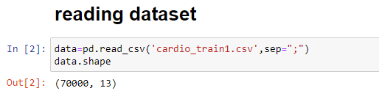

The dataset contains 7000 rows and 13 columns.

4.3 DATA PREPARATION AND DATA PREPROCESSING

To get the snap shot of the data, by getting first few rows and last few rows of the data frame i.e.; Head and Tail function in python. Head function returns first n rows and tail function return last n rows.

Pandas head () method is used to return top n (5 by default) rows of a data frame or series.

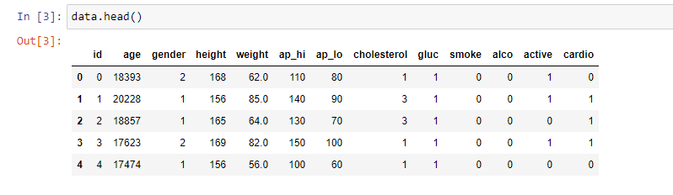

Pandas tail () method is used to return bottom n (5 by default) rows of a data frame or series.

Pandas info () is used to view the basic details like column name, null values, dtypes, memory usage.

Pandas describe () is used to view some basic statistical details like percentile, mean, std etc. of a data frame or a series of numeric values.
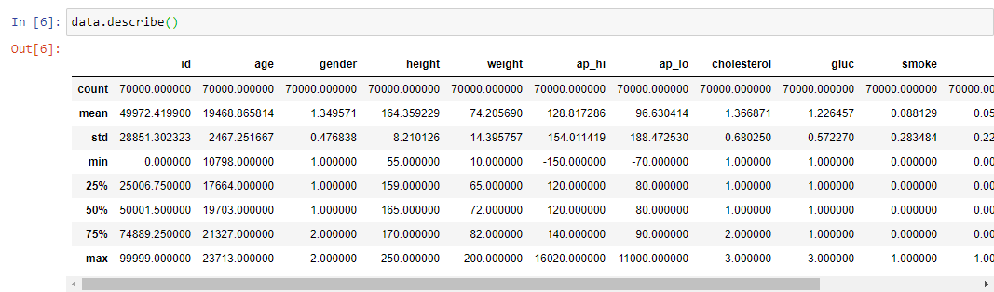

4.3.1 CHECKING MISSING VALUES

Pandas isna() function is used to detect missing values. Here the dataset contains no missing values.
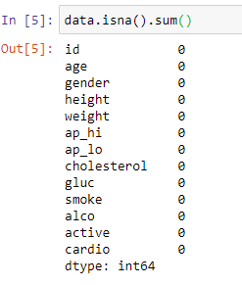

4.3.2 Converting age from days to years and dropping Id attribute

Age is given in days so we have to transform it into years for better understanding and checking relation with the target variable

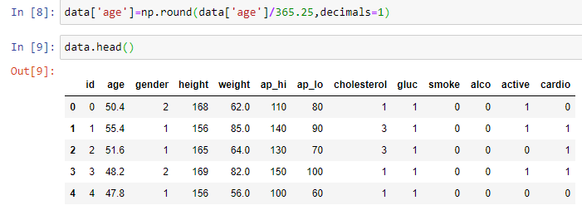

column 'id’ is irrelevant to target variable. So, we can drop it.

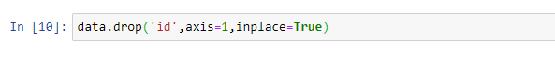

4.3.3 HANDLING THE OUTLIERS

An outlier is an observation that lies in an abnormal distance from other values in a random sample from a population.
The box plot is a useful graphical display for describing the behavior of the data in the middle as well as at the end of the observations. The boxplot uses the median and the lower and the upper quartiles.
The boxplot visualization of the the features are given below.
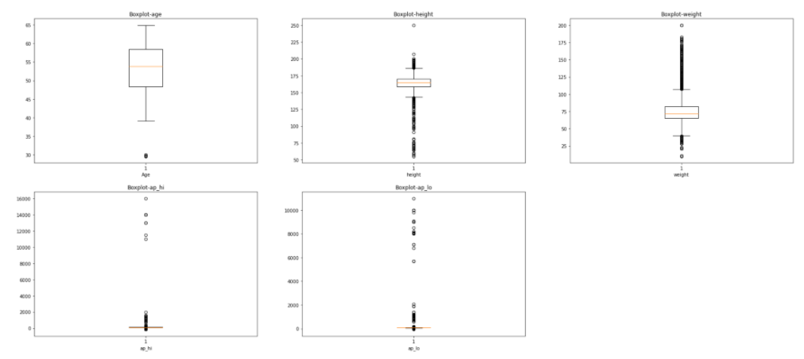

From the box plot it is clear that there are some outliers in our dataset. As we have seen with the describe function above the minimum values in systolic blood pressure and diastolic blood pressure are negative, which is not possible in real case. So, they are outliers. Similarly, minimum and maximum height sounds faulty. Same for age and weight. These are outliers
To remove the outliers, we have used Inter Quartile Range method.

IQR is used to measure variability by dividing a data set into quartiles. The data is sorted in ascending order and split into 4 equal parts. Q1, Q2, Q3 called first, second and third quartiles are the values which separate the 4 equal parts.

Q1 represents the 25th percentile of the data, Q2 represents the 50th percentile of the data and Q3 represents the 75th percentile of the data. IQR is the range between the first and the third quartiles namely Q1 and Q3: IQR = Q3 – Q1. The data points which fall below Q1 – 1.5 IQR or above Q3 + 1.5 IQR are outliers.

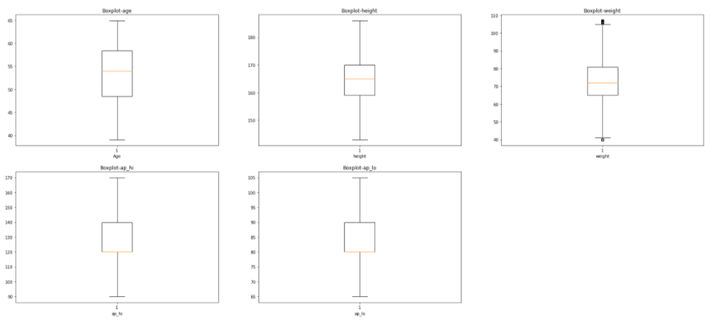
Now the dataset is almost ready. After removing outliers and irrelevant attribute we have 62502 samples with 12 attributes remaining
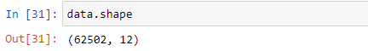

4.4. DATA VISUALIZATION

Data visualization is the graphical representation of information and data. By using visual elements like charts, graphs, and maps, data visualization tools provide an accessible way to see and understand trends, outliers, and patterns in data. Found this to be an interesting graphic. Useful insights of the data can be gained through data visualization. The visualization of the features in this dataset are shown below.

COUNT PLOT

- We have plotted the count plot of our target variable to check whether the dataset is balanced or not

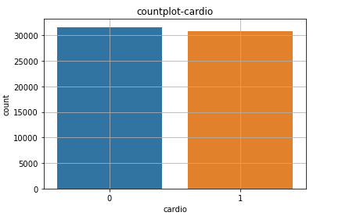
From the graph it is clear that both the target values have almost same count. So, we don’t have to worry about any imbalance in the dataset. Our dataset is pretty balanced.

- In our dataset no information is given about which number denotes male and which denote female in gender attribute, to find that we have plotted a bar plot of gender and height and weight.

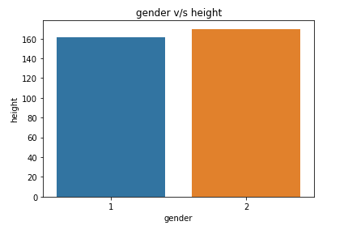
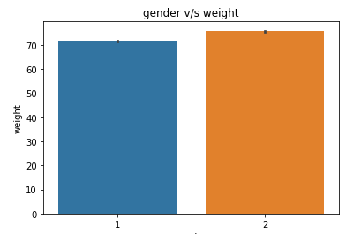
By the assumption men have larger height and weight than female we conclude that number 1 denotes females and 2 denotes male.

DISTRIBUTION PLOT

- We have plotted the distribution plot of all the continuous features in our dataset, i.e., age, height, weight, ap_hi, ap_lo.

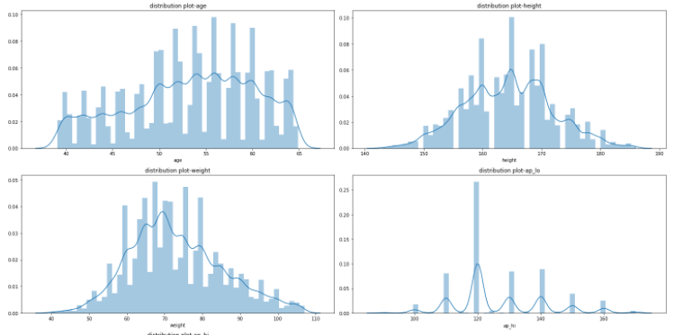

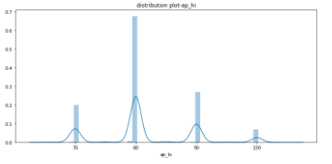

All the five features are a normally distributed.

- We have plotted the age distribution graph

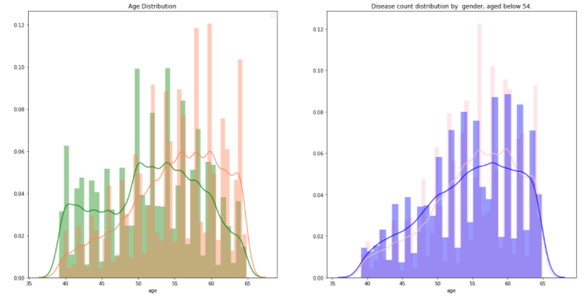

From the figures it is clear that People above the age of 54 are more likely to have diseased than below, also males below 50 are more likely to have been diagnosed with heart disease than females which confirms our assumption, even though the difference is not that drastic.

BAR PLOT

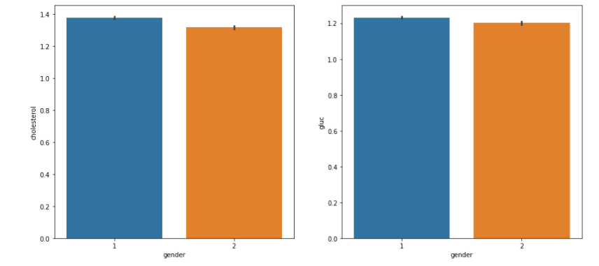

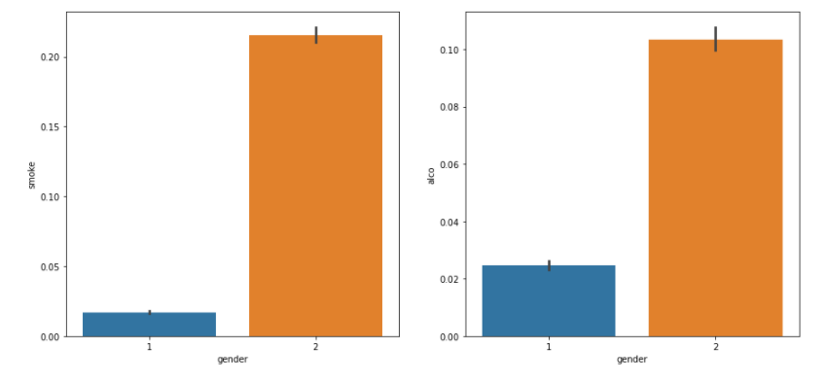

From the bar plots we can understand that female patients have high cholesterol and glucose than male patients. Similarly smoking and alcohol taking habit is higher with men than female
CORRELATION HEATMAP

To know the correlation between features and with target we have plotted the correlation heatmap
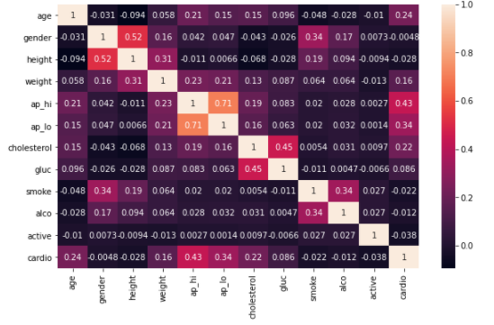
1) ap_hi and ap_lo are highly positively correlated to each other
2) gender and height are also positively correlated to each other
3)ap_hi and ap_lo are positively correlated to target variable than other features

4.5 FEATURE ENGINEERING

Since we have height and weight, we can calculate BMI. It seems better to get another Feature BMI
BMI=weight in kilograms/ (height in meter) ^2
Bases on BMI values we have created 4 categories
- If BMI<18.5 BMI is set to 1 which denotes under weight
- If 18.8<=BMI<25 BMI is set to 2 which denotes normal
- If 25<=BMI<30 BMI is set to 3 which denotes overweight
- If BMI>=30 BMI is set to 4 which denotes obesity

Then we have dropped the height and weight attribute from the dataset

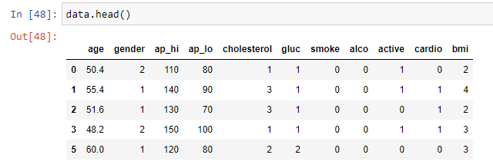

4.6 STANDARD SCALING

In our dataset the features are in different scale. So, we need to scale them before feeding into the model. We have three continuous features in our dataset after all preprocessing and data preparation steps which are age, ap_hi, and ap_lo. The remaining features are categorical ordinal features. We need to apply standard scaling to only the numeric continuous features. Before standard scaling the features are stored in variable X and target is stored in variable y.
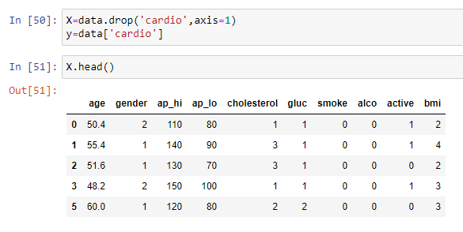

Standardization scales each input variable separately by subtracting the mean (called centering) and dividing by the standard deviation to shift the distribution to have a mean of zero and a standard deviation of one.

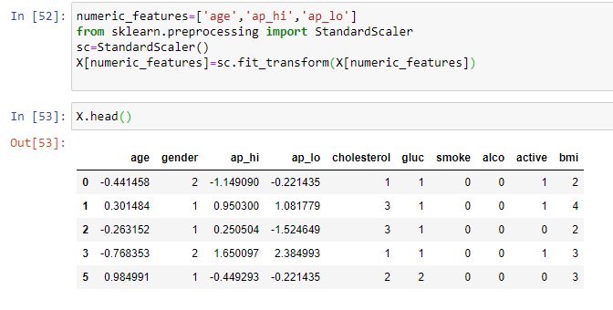

4.7 DATA MODELING

4.7.1. Train test splitting:

Before giving data into the machine learning models, we have to split the data into test and train sets. Train test splitting is done using train_test_split () function in sklearn. We have used 70% of the data for training and 30 % for testing. The training set consist of 43751 samples with 10 features and test set consists of 18751 samples with 10 features.

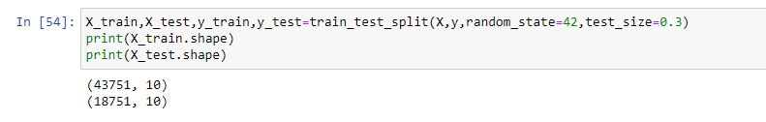

4.7.2. APPLYING DIFFERENT MACHINE LEARNING MODELS

LOGISTIC REGRESSION

A logistic regression model predicts a dependent data variable by analyzing the relationship between one or more existing independent variables. Logistic regression has become an important tool in the discipline of machine learning.

KNN

K Nearest Neighbour is one of the fundamental algorithms in machine learning. Machine learning models use a set of input values to predict output values. KNN is one of the simplest forms of machine learning algorithms mostly used for classification. It classifies the data point on how its neighbour is classified.
KNN classifies the new data points based on the similarity measure of the earlier stored data points. KNN will store similar measures like shape and color. When a new object comes it will check its similarity with the color and shape.
K in KNN represents the number of the nearest neighbors we used to classify new data points.
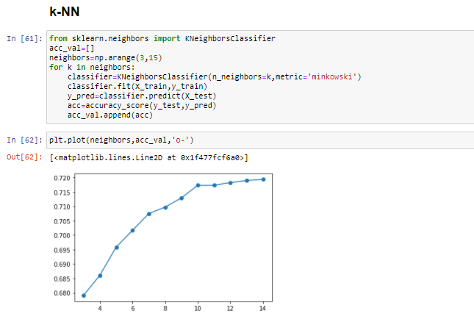
From the graph it is clear that the accuracy is maximum when k=14
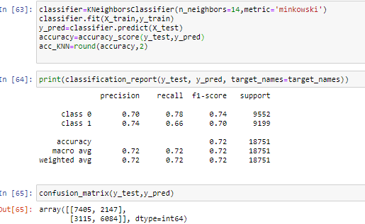

DECISION TREE

Decisions Trees is a powerful group of supervised Machine Learning models that can be used for both classification and regression. Decision Trees have been some of the Machine Learning models to deliver the best results at competitions.

Decision trees are one of the most fundamental Machine Learning tools which are used for both classification and regression tasks

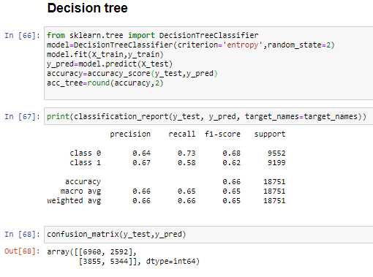

SVM-LINEAR

Linear SVM is the newest extremely fast machine learning (data mining) algorithm for solving multiclass classification problems from ultra large data sets that implements an original proprietary version of a cutting plane algorithm for designing a linear support vector machine.

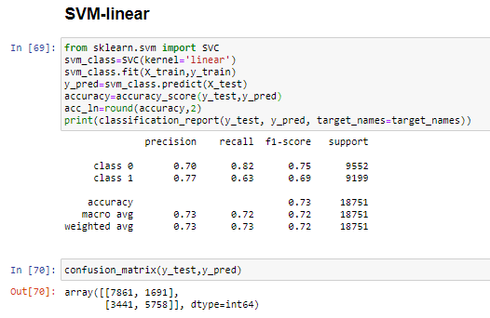
SVM-POLYNOMIAL

In machine learning, the polynomial kernel is a kernel function commonly used with support vector machines (SVMs) and other kernelized models, that represents the similarity of vectors (training samples) in a feature space over polynomials of the original variables, allowing learning of non-linear models.

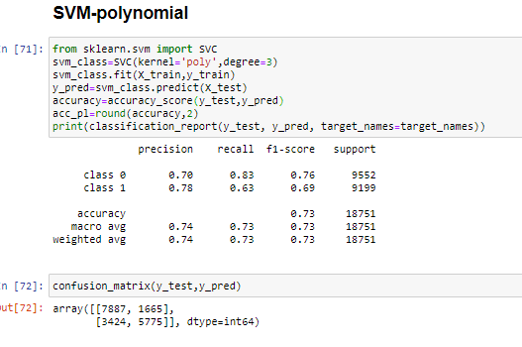

SVM-rbf

In machine learning, the radial basis function kernel, or RBF kernel, is a popular kernel function used in various kernelized learning algorithms. In particular, it is commonly used in support vector machine classification.
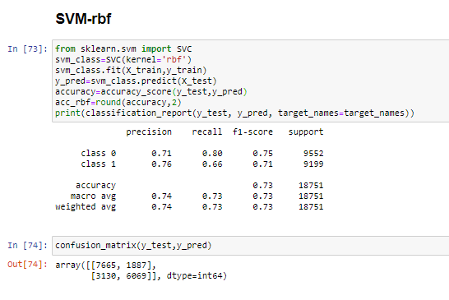

RANDOM FOREST

Random forests or random decision forests are an ensemble learning method for classification, regression and other tasks that operate by constructing a multitude of decision trees at training time and outputting the class that is the mode of the classes (classification) or mean/average prediction (regression) of the individual trees

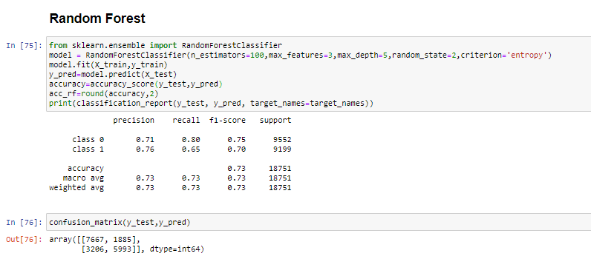

GRADIENT BOOSTING

Gradient boosting is a machine learning technique for regression and classification problems, which produces a prediction model in the form of an ensemble of weak prediction models, typically decision trees.

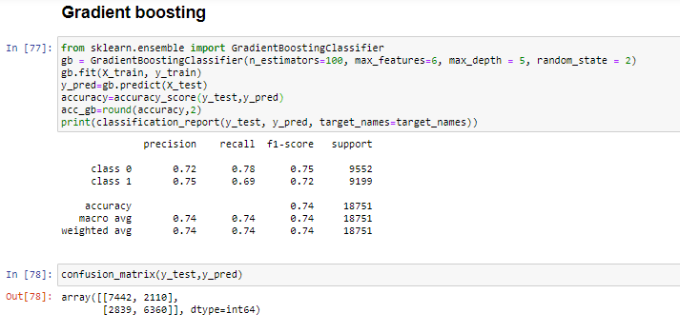

XGB

It is an ensemble machine learning technique that uses the Gradient boosting framework for machine learning prediction and XGBoost is well known for its fast execution and Scalability.
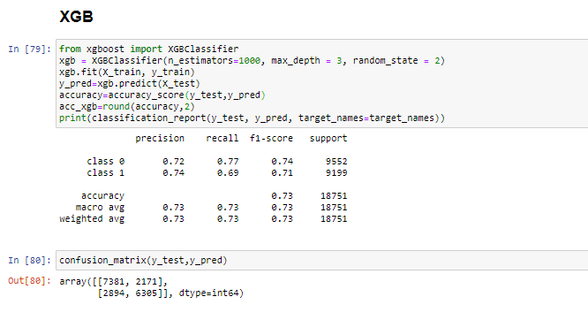

GRAPH OF THE ACCURACY OBTAINED

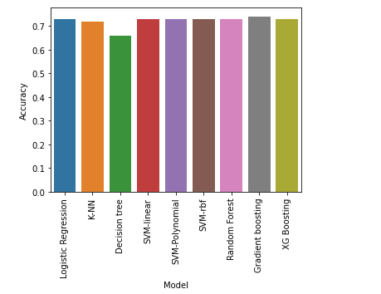

5. RESULT AND ANALYSIS

We have obtained a maximum accuracy of 74 % when gradient boosting is used. The accuracy comparison of different models is given in the table

ALGORITHMS | ACCURACY OBTAINED
LOGISTIC REGRESSION | 0.0.73  0.73
K-NN | 0.72
DECISION TREE | 0.66
SVM – LINEAR | 0.73
SVM – POLYNOMIAL | 0.73
SVM – RADIAL | 0.73
RANDOM FOREST | 0.73
GRADIENT BOOSTING | 0.74
XGB | 0.73

6. CONCLUSION

Cardiovascular diseases (CVDs) are the number 1 cause of death globally, taking an estimated 17.9 million lives each year. CVDs are a group of disorders of the heart and blood vessels and include coronary heart disease, cerebrovascular disease and other conditions. Identifying those at highest risk of CVDs and ensuring they receive appropriate treatment can prevent premature deaths. Here comes the need for a good and efficient prediction frame work for CVD. We have built a prediction system using machine learning model Gradient boosting which predicts whether a person is healthy or suffering from CVD with an accuracy of 74%.
This model will be helpful for people who does not know anything about the big big terms in medical system. They can check their chance of being affected by CVD at the ease of sitting in their home by giving the required features and they can take necessary treatments by going to the hospital. The model will be also helpful for doctors and other medical professionals to avoid making any wrong decision. If person with CVD is treated as healthy then it may incur heavy loss. So the doctors can make a confirmation on the decision taken by him by using our model.

Our model is less expensive and any one can use this model to check their chance of CVD.

7. REFERENCES

1. https://www.kaggle.com/sulianova/cardiovascular-disease-dataset

